Thông tin về giảm tiểu cầu trong bệnh lý sốt rét, sốt xuất huyết và nhiễm trùng

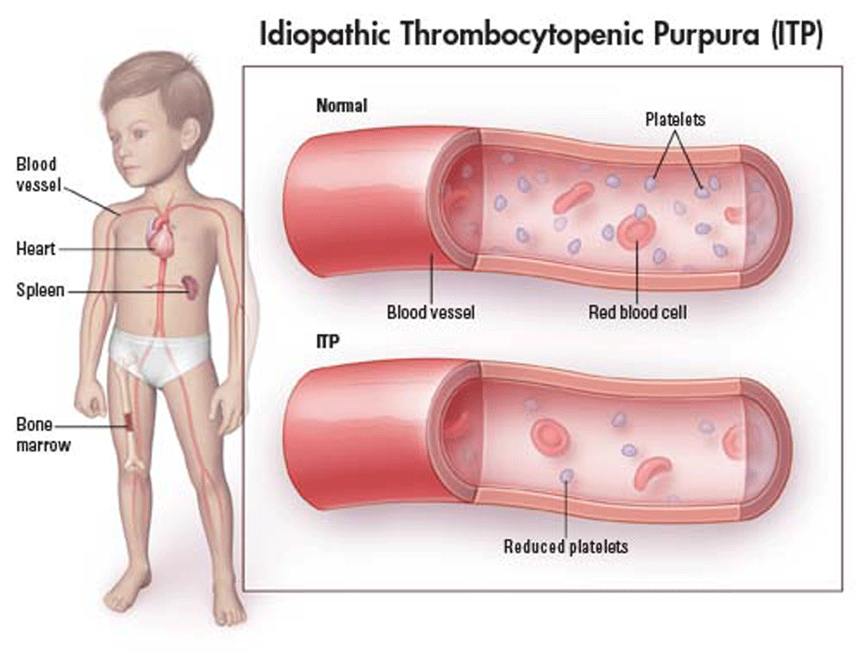
Nhằm chia sẻ thông tin từ câu hỏi của 3 bạn đọc, cùng các đồng nghiệp ở Phú Yên và Đăk Nông về lý do tại sao lại có hiện tượng giảm tiểu cầu trong bệnh sốt rét, vì bệnh sốt xuất huyết đã có giảm tiểu cầu rồi, nay sốt rét cũng giảm tiểu cầu thì nguy cơ chẩn đoán nhầm lẫn giữa hai bệnh này là rất cao nếu không có kinh nghiệm.

Chúng tôi xin chuyển đến một số nghiên cứu sâu về chuyên ngành cũng như các nghiên cứu đánh giá giảm tiểu cầu như thế nào và cơ sở lý thuyết cũng như một số điểm mới trong cơ chế bệnh sinh.
- Correia, Maria C.B.; Domingues, Ana L.C.; Lacerda, Heloisa R.; Santos, Emília M.; MacHado, CíNtia G.F.; Hora, Viviane; Neves, Maria A.; Brito, Anelita et al. (2009). "Platelet function and the von Willebrand factor antigen in the hepatosplenic form of schistosomiasis mansoni". Transactions of the Royal Society of Tropical Medicine and Hygiene 103 (10): 1053–8.
- Cheung, R; McAuley, R; Pollard, J (2005). "High mortality rate in patients with advanced liver disease independent of exposure to general anesthesia". Journal of Clinical Anesthesia 17 (3): 172–6.
- Scaradavou, A (2002). "HIV-related thrombocytopenia". Blood Reviews 16 (1): 73–6.
- Watson, T. D; Stark, JE; Vesta, KS (2006). "Pantoprazole-Induced Thrombocytopenia". Annals of Pharmacotherapy 40 (4): 758–61.
- Motoki, Fijita; Susumu, Yamashita; Nobukatsu, Kawamura; Ryosuke, Tsuruta; Shunji, Kasaoka; Kiyoshi, Okabayashi; Tsuyoshi, Maekawa (2005). "Viper (Agkistrodon halys blomhoffii 'Mamushi') Bite with Remarkable Thrombocytopenia". Journal of Japanese Association for Acute Medicine 16 (3): 126–30.
- Furlan, M; Lämmle, Bernhard (2001). "Aetiology and pathogenesis of thrombotic thrombocytopenic purpura and haemolytic uraemic syndrome: the role of von Willebrand factor-cleaving protease". Best Practice & Research Clinical Haematology 14 (2): 437–54.
- Tsai, H.-M. (2003). "Advances in the Pathogenesis, Diagnosis, and Treatment of Thrombotic Thrombocytopenic Purpura". Journal of the American Society of Nephrology 14 (4): 1072–81.
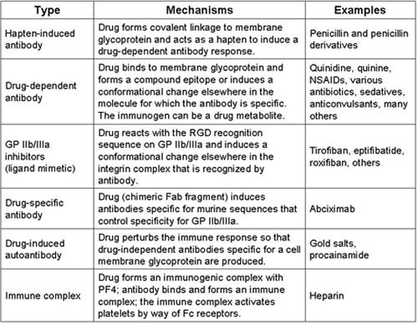
- Bussel, James B.; Kuter, David J.; George, James N.; McMillan, Robert; Aledort, Louis M.; Conklin, George T.; Lichtin, Alan E.; Lyons, Roger M. et al. (2006). "AMG 531, a Thrombopoiesis-Stimulating Protein, for Chronic ITP". New England Journal of Medicine 355 (16): 1672–81.
- AMGEN (2008-03-12). "Press release: Amgen Statement on Successful Outcome of Romiplostim Panel Meeting". Business Wire via drugs.com. Retrieved 2008-05-22.
- Richwine, Lisa (2008-03-12). "US FDA panel backs Amgen's Nplate against ITP". Reuters. Retrieved 2008-05-22.
- Roberts, I; Murray, NA (2003). "Neonatal thrombocytopenia: causes and management". Archives of Disease in Childhood - Fetal and Neonatal Edition 88 (5): F359–64.
- Guida, JD; Kunig, AM; Leef, KH; McKenzie, SE; Paul, DA (2003). "Platelet count and sepsis in very low birth weight neonates: is there an organism-specific response?". Pediatrics 111 (6 Pt 1): 1411–5.
- Klein, JO (1990). "Bacteriology of neonatal sepsis". The Pediatric Infectious Disease Journal 9 (10): 778.
- D Dzierzanowska (2001). Antybiotykoterapia praktyczna.
- Pacifico, L; Chiesa, C; Mirabella, S; Panero, A; Midulla, M (1987). "Early-onset Pseudomonas aeruginosa sepsis and Yersinia enterocolitica neonatal infection: a unique combination in a preterm infant". European journal of pediatrics 146 (2): 192–3.
- Rempen, A; Martius, J; Hartmann, AA; Wecker, I (1987). "Transmission rate of Ureaplasma urealyticum, Mycoplasma spp., Gardnerella vaginalis, B-streptococci, Candida spp. and Chlamydia trachomatis from the mother to the newborn". Archives of gynecology and obstetrics 241 (3): 165–70.
- Olver, WJ; Bond, DW; Boswell, TC; Watkin, SL (2000). "Neonatal group B streptococcal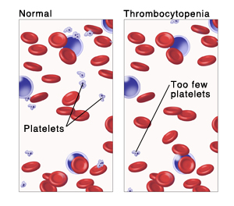 disease associated with infected breast milk". Archives of disease in childhood. Fetal and neonatal edition 83 (1): F48–9.
- Kotiw, M; Zhang, GW; Daggard, G; Reiss-Levy, E; Tapsall, JW; Numa, A (2003). "Late-onset and recurrent neonatal Group B streptococcal disease associated with breast-milk transmission". Pediatric and developmental pathology : the official journal of the Society for Pediatric Pathology and the Paediatric Pathology Society 6 (3): 251–6.
- Gastelum, DT; Dassey, D; Mascola, L; Yasuda, LM (2005). "Transmission of community-associated methicillin-resistant Staphylococcus aureus from breast milk in the neonatal intensive care unit". The Pediatric Infectious Disease Journal 24 (12): 1122–4.
- Jagielski, Marek; Rastawicki, Waldemar; Kałużewski, Stanisław; Gierczyński, Rafał (2007). "Jersinioza – niedoceniana choroba zakaźna" [Yersiniosis – unappreciated infectious diseases]. Przegl Epidemiol (in Polish) 56 (1): 57–64.
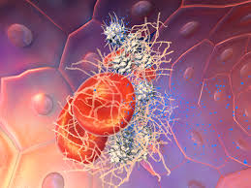
- Mielczarek, Paweł (2004). "Jersinioza – rzadko rozpoznawana choroba układu pokarmowego" [Yersiniosis – rarely diagnosed disease of gastrointestinal system]. Prace poglądowe (in Polish) 11 (1): 69–74.
- Aggarwal A, Rath S, Shashiraj 2005. Plasmodium vivax malaria presenting with severe thrombocytopenia. J Trop Pediatr 51: 120-121.
- Alecrim MGC 2000. Clinical aspects, resistance and parasitary polymorphism of Plasmodium vivax malaria in Manaus, PhD Thesis, Universidade de Brasília, Brasília, 176 pp.
- Alexandre MA, Ferreira CO, Siqueira AM, Magalhaes BL, Mourao MPG, Lacerda MVG, Alecrim MGC 2010. Severe Plasmodium vivax malaria, Brazilian Amazon. Emerg Infect Dis 16: 1611-1614.
- Almeida AJ 2003. Trombocitopenia associada ao HCV: aspectos clínico-laboratoriais e virológicos, MD Thesis, Fundação Oswaldo Cruz, Rio de Janeiro, 110 pp.
- Andrade BB, Reis-Filho A, Souza-Neto SM, Clarencio J, Camargo LM, Barral A, Barral-Netto M 2010. Severe Plasmodium vivax malaria exhibits marked inflammatory imbalance. Malar J 9: 13.
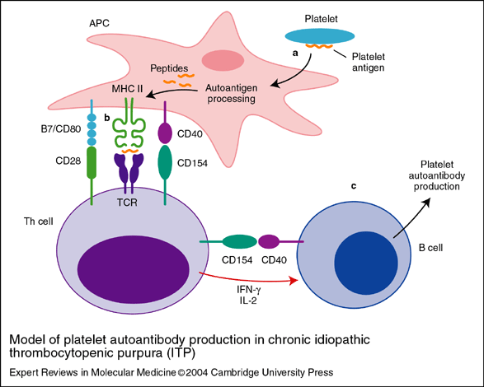
- Anstey NM, Currie BJ, Dyer ME 1992. Profound thrombocytopenia due to Plasmodium vivax malaria. Aust N Z J Med 22: 169-170.
- Araujo CF, Lacerda MV, Abdalla DS, Lima ES 2008. The role of platelet and plasma markers of antioxidant status and oxidative stress in thrombocytopenia among patients with vivax malaria. Mem Inst Oswaldo Cruz 103: 517-521.
- Araújo Filho JA, Bressan FR, Tourinho TM, Souza MVL, Pereira LI 2003. Plaquetopenia acentuada associada à malária pelo P. vivax. Anais do XIII Congresso Brasileiro de Infectologia, Goiânia. Braz J Infect Dis 7 (Suppl. 1): 25.
- Bashawri LA, Mandil AA, Bahnassy AA, Ahmed MA 2002. Malaria: hematological aspects. Ann Saudi Med 22: 372-376.
- Beale PJ, Cormack JD, Oldrey TB 1972. Thrombocytopenia in malaria with immunoglobulin (IgM) changes. BMJ 1: 345-349.
- Becchi C, Al Malyan M, Fabbri LP, Marsili M, Boddi V, Boncinelli S 2006. Mean platelet volume trend in sepsis: is it a useful parameter? Minerva Anestesiol 72: 749-756.
- Bhatia V, Bhatia J 2010. Severe thrombocytopenia with bleeding manifestations in two children secondary to Plasmodium vivax. Platelets 21: 307-309.
- Blajchman MA 2003. Substitutes and alternatives to platelet transfusions in thrombocytopenic patients. J Thromb Haemost 1: 1637-1641.
- Brown KM, Kreier JP 1982. Plasmodium berghei malaria: blockage by immune complexes of macrophage receptors for opsonized plasmodia. Infect Immun 37: 1227-1233.
- Campos FM, Franklin BS, Teixeira-Carvalho A, Filho AL, de Paula SC, Fontes CJ, Brito CF, Carvalho LH 2010. Augmented plasma microparticles during acute Plasmodium vivax infection. Malar J 9: 327.
- Carvalho BO, Lopes SC, Nogueira PA, Orlandi PP, Bargieri DY, Blanco YC, Mamoni R, Leite JA, Rodrigues MM, Soares IS, Oliveira TR, Wunderlich G, Lacerda MV, Del Portillo HA, Araujo MO, Russell B, Suwanarusk R, Snounou G, Renia L, Costa FT 2010. On the cytoadhesion of Plasmodium vivax-infected erythrocytes. J Infect Dis 202: 638-647.
- Casals-Pascual C, Kai O, Newton CR, Peshu N, Roberts DJ 2006. Thrombocytopenia in falciparum malaria is associated with high concentrations of IL-10. Am J Trop Med Hyg 75: 434-436.
- Chagas C 1903. Hematological studies of impaludism, MD Thesis, Manguinhos Institute, Rio de Janeiro, 143 pp.
- Chotivanich K, Sritabal J, Udomsangpetch R, Newton P, Stepniewska KA, Ruangveerayuth R, Looareesuwan S, Roberts DJ, White NJ 2004. Platelet-induced autoagglutination of Plasmodium falciparum-infected red blood cells and disease severity in Thailand. J Infect Dis 189: 1052-1055.
- Combes V, Coltel N, Faille D, Wassmer SC, Grau GE 2006. Cerebral malaria: role of microparticles and platelets in alterations of the blood-brain barrier. Int J Parasitol 36: 541-546.
- Conte R, Tassi C, Belletti D, Ricci F, Tazzari PL 2003. Autoimmune thrombocytopenia in malaria. Vox Sang 85: 221.
- Cummins D, Faint R, Yardumian DA, Dawling S, Mackie I, Machin SJ 1990. The in vitro and ex vivo effects of chloroquine sulphate on platelet function: implications for malaria prophylaxis in patients with impaired haemostasis. J Trop Med Hyg 93: 112-115.
- D'Acremont V, Landry P, Mueller I, Pecoud A, Genton B 2002. Clinical and laboratory predictors of imported malaria in an outpatient setting: an aid to medical decision making in returning travelers with fever. Am J Trop Med Hyg 66: 481-486.
- Daniel-Ribeiro CT 2000. Is there a role for autoimmunity in immune protection against malaria? Mem Inst Oswaldo Cruz 95: 199-207.
- Daniel-Ribeiro CT, Zanini G 2000. Autoimmunity and malaria: what are they doing together? Acta Trop 76: 205-221.
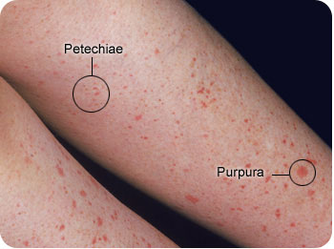
- Davidson RA 1985. Immunology of parasitic infections. Med Clin North Am 69: 751-758.
- de Paula LV, Klafke A, Bordin R, Pereira JPM, Job FM 1993. Avaliação da eficácia das transfusões de concentrados de plaquetas nos Serviços de Hematologia e Hemoterapia do Hospital de Clínicas de Porto Alegre. Bol Soc Bras Hematol Hemoter 15: 9-13.
- del Portillo HA, Lanzer M, Rodriguez-Malaga S, Zavala F, Fernandez-Becerra C 2004. Variant genes and the spleen in Plasmodium vivax malaria. Int J Parasitol 34: 1547-1554.
- Dennis LH, Eichelberger JW, Inman MM, Conrad ME 1967. Depletion of coagulation factors in drug-resistant Plasmodium falciparum malaria. Blood 29: 713-721.
- Doi T, Homma H, Mezawa S, Kato J, Kogawa K, Sakamaki S, Niitsu Y 2002. Mechanisms for increment of platelet associated IgG and platelet surface IgG and their implications in immune thrombocytopenia associated with chronic viral liver disease. Hepatol Res 24: 23.
- Echeverri M, Tobon A, Alvarez G, Carmona J, Blair S 2003. Clinical and laboratory findings of Plasmodium vivax malaria in Colombia 2001. Rev Inst Med Trop Sao Paulo 45: 29-34.
- Engwerda CR, Beattie L, Amante FH 2005. The importance of the spleen in malaria. Trends Parasitol 21: 75-80.
- Erel O, Kocyigit A, Bulut V, Avci S, Aktepe N 1998. Role of lipids, lipoproteins and lipid peroxidation in thrombocytopenia in patients with vivax malaria. Haematologia (Budap) 29: 207-212.
- Erel O, Vural H, Aksoy N, Aslan G, Ulukanligil M 2001. Oxidative stress of platelets and thrombocytopenia in patients with vivax malaria. Clin Biochem 34: 341-344.
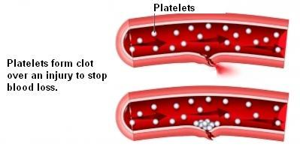
- Essien EM, Ebhota MI 1981. Platelet hypersensitivity in acute malaria (Plasmodium falciparum) infection in man. Thromb Haemost 46: 547-549.
- Fajardo LF, Tallent C 1974. Malarial parasites within human platelets. J Am Med Assoc 229: 1205-1207.
- Franchini M 2005. Pathophysiology, diagnosis and treatment of disseminated intravascular coagulation: an update. Clin Lab 51: 633-639.
- George P, Alexander LM 2010. A study on the clinical profile of complicated Plasmodium vivax mono-infections. Asian Pac J Trop Med 3: 560-562.
- Gerardin P, Rogier C, Ka AS, Jouvencel P, Brousse V, Imbert P 2002. Prognostic value of thrombocytopenia in African children with falciparum malaria. Am J Trop Med Hyg 66: 686-691.
- Gonzalez B, Rodulfo H, De Donato M, Berrizbeitia M, Gomez C, Gonzalez L 2009. Hematologic variations in patient with malaria caused by Plasmodium vivax before, during and after treatment. Invest Clin 50: 187-201.
- Gonzalez LM, Guzman M, Carmona J, Lopera T, Blair S 2000. Clinical and epidemiologic characteristics of 291 hospitalized patients for malaria in Medellin (Colombia). Acta Med Colomb 25: 163-170.
- Grau GE, Piguet PF, Gretener D, Vesin C, Lambert PH 1988. Immunopathology of thrombocytopenia in experimental malaria. Immunology 65: 501-506.
- Greenwood BM 1968. Autoimmune disease and parasitic infections in Nigerians. Lancet 2: 380-382.
- Grynberg P, Fernandes Fontes CJ, Braga EM 2007. Association between particular polymorphic residues on apical membrane antigen 1 (AMA-1) and platelet levels in patients with vivax malaria. Clin Microbiol Infect 13: 1089-1094.
- Harish R, Gupta S 2009. Plasmodium vivax malaria presenting with severe thrombocytopenia, cerebral complications and hydrocephalus. Indian J Pediatr 76: 551-552.
- Hill GJ, Knight V, Jeffery GM 1964. Thrombocytopenia in vivax malaria. Lancet 39: 240-241.
- Hoffman SL, Rustama D, Punjabi NH, Surampaet B, Sanjaya B, Dimpudus AJ, McKee KT, Jr., Paleologo FP, Campbell JR, Marwoto H 1988. High-dose dexamethasone in quinine-treated patients with cerebral malaria: a double-blind, placebo-controlled trial. J Infect Dis 158: 325-331.
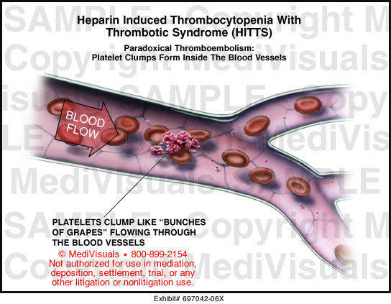
- Holland BH, Walker AN, Collier L, Stephens JL 2004. Severe thrombocytopenia and epistaxis secondary to Plasmodium vivax infection. Internet J Infect Dis 3. Available from: ispub.com/ostia/index.php?xmlFilePath=journals/ijid/vol3n2/vivax.xml.
- Honda S, Saito M, Dimaano EM, Morales PA, Alonzo MT, Suarez LA, Koike N, Inoue S, Kumatori A, Matias RR, Natividad FF, Oishi K 2009. Increased phagocytosis of platelets from patients with secondary dengue virus infection by human macrophages. Am J Trop Med Hyg 80: 841-845.
- Huang DB, DuPont HL 2005. Problem pathogens: extra-intestinal complications of Salmonella enterica serotype typhi infection. Lancet Infect Dis 5: 341-348.
- Inyang AL, Sodeinde O, Okpako DT, Essien EM 1987. Platelet reactions after interaction with cultured Plasmodium falciparum infected erythrocytes. Br J Haematol 66: 375-378.
- Jadhav UM, Patkar VS, Kadam NN 2004. Thrombocytopenia in malaria - correlation with type and severity of malaria. J Assoc Physicians India 52: 615-618.
- Jaff MS, McKenna D, McCann SR 1985. Platelet phagocytosis: a probable mechanism of thrombocytopenia in Plasmodium falciparum infection. J Clin Pathol 38: 1318-1319.
- Kakar A, Bhoi S, Prakash V, Kakar S 1999. Profound thrombocytopenia in Plasmodium vivax malaria. Diagn Microbiol Infect Dis 35: 243-244.
- Karpatkin S 2002. HIV-1 related thrombocytopenia. In AD Michelson, Platelets, Elsevier Academic Press, California, p. 559-570.
- Karpatkin S, Nardi MA, Hymes KB 1995. Sequestration of anti-platelet GPIIIa antibody in rheumatoid factor immune complexes of human immunodeficiency virus 1 thrombocytopenic patients. Proc Natl Acad Sci USA 92: 2263-2267.
- Katira B, Shah I 2006. Thrombocytopenia in Plasmodium vivax infected children. J Vector Borne Dis 43: 147-149.
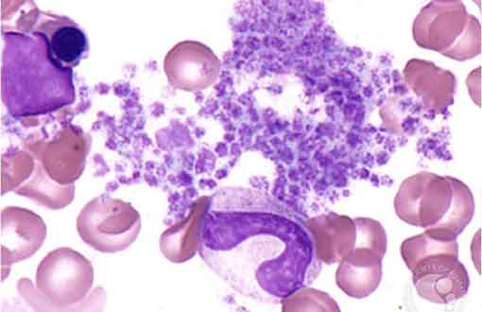
- Kaur D, Wasir V, Gulati S, Bagga A 2007. Unusual presentation of Plasmodium vivax malaria with severe thrombocytopenia and acute renal failure. J Trop Pediatr 53: 210-212.
- Kelton JG, Keystone J, Moore J, Denomme G, Tozman E, Glynn M, Neame PB, Gauldie J, Jensen J 1983. Immune-mediated thrombocytopenia of malaria. J Clin Invest 71: 832-836.
- Khan FY, Lutof AK, Yassin MA, Khattab MA, Saleh M, Rezeq HY, Almaslamani M 2009. Imported malaria in Qatar: a one year hospital-based study in 2005. Travel Med Infect Dis 7: 111-117.
- Kochar DK, Das A, Kochar A, Middha S, Acharya J, Tanwar GS, Gupta A, Pakalapati D, Garg S, Saxena V, Subudhi AK, Boopathi PA, Sirohi P, Kochar SK 2010. Thrombocytopenia in Plasmodium falciparum, Plasmodium vivax and mixed infection malaria: a study from Bikaner (Northwestern India). Platelets 21: 623-627.
- Kochar DK, Saxena V, Singh N, Kochar SK, Kumar SV, Das A 2005. Plasmodium vivax malaria. Emerg Infect Dis 11: 132-134.
- Koltas IS, Demirhindi H, Hazar S, Ozcan K 2007. Supportive presumptive diagnosis of Plasmodium vivax malaria. Thrombocytopenia and red cell distribution width. Saudi Med J 28: 535-539.
- Komoda M, Fujimoto T, Kawaguchi Y, Tsushima H, Fukushima T, Hata T, Miyazaki Y, Tsukasaki K, Tomonaga M 2006. Plasmodium vivax malaria with clinical presentation mimicking acute type idiopathic thrombocytopenic purpura (abstract). Rinsho Ketsueki 47: 1453-1456.
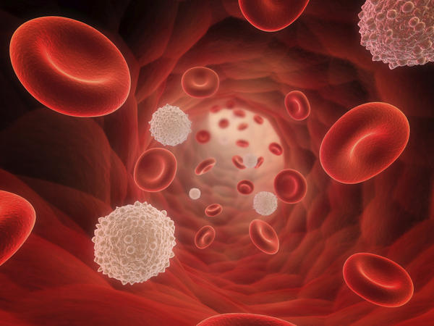
- Kortepeter M, Brown JD 1998. A review of 79 patients with malaria seen at a military hospital in Hawaii from 1979 to 1995. Mil Med 163: 84-89.
- Kreil A, Wenisch C, Brittenham G, Looareesuwan S, Peck-Radosavljevic M 2000. Thrombopoietin in Plasmodium falciparum malaria. Br J Haematol 109: 534-536.
- Kumar A, Shashirekha 2006. Thrombocytopenia: an indicator of acute vivax malaria. Indian J Pathol Microbiol 49: 505-508.
- Lacerda MV, Alexandre MA, Santos PD, Arcanjo AR, Alecrim WD, Alecrim MGC 2004. Idiopathic thrombocytopenic purpura due to vivax malaria in the Brazilian Amazon. Acta Trop 90: 187-190.
- Lacerda MV, Hipolito JR, Passos LN 2008. Chronic Plasmodium vivax infection in a patient with splenomegaly and severe thrombocytopenia. Rev Soc Bras Med Trop 41: 522-523.
- Lacerda MVG 2007. Manifestações clínicas e patogênese da plaquetopenia na malária, PhD Thesis, Universidade de Brasília, 439 pp.
- Lacerda MVG, Cavalcante TB, Silva AC, Macêdo VO 2006. Avaliação das indicações de transfusão de concentrado de plaquetas. Anais do XLII Congresso da Sociedade Brasileira de Medicina Tropical, Teresina. Rev Soc Bras Med Trop 39 (Suppl. I): 104.
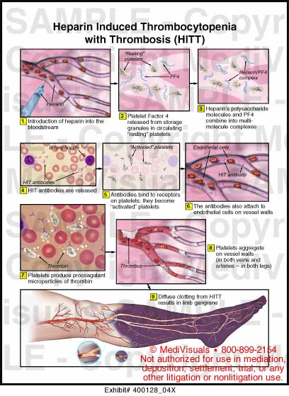
- Lacerda MVG, Mourão MPG, Alecrim WD, Alecrim MGC 2001. Clinical study of patients with falciparum malaria admitted to the Tropical Medicine Foundation of Amazonas - Brazil. Annals of the 50th Annual Meeting of the American Society of Tropical Medicine and Hygiene, Atlanta (USA). Am J Trop Med Hyg 65: 336.
- Lacerda MVG, Oliveira SL, Alecrim MGC 2007. Splenic hematoma in a patient with Plasmodium vivax malaria. Rev Soc Bras Med Trop 40: 96-97.
- Ladhani S, Lowe B, Cole AO, Kowuondo K, Newton CR 2002. Changes in white blood cells and platelets in children with falciparum malaria: relationship to disease outcome. Br J Haematol 119: 839-847.
- Lathia TB, Joshi R 2004. Can hematological parameters discriminate malaria from nonmalarious acute febrile illness in the tropics? Indian J Med Sci 58: 239-244.
- Lee SH, Looareesuwan S, Chan J, Wilairatana P, Vanijanonta S, Chong SM, Chong BH 1997. Plasma macrophage colony-stimulating factor and P-selectin levels in malaria-associated thrombocytopenia. Thromb Haemost 77: 289-293.
- Li Z, Nardi MA, Karpatkin S 2005. Role of molecular mimicry to HIV-1 peptides in HIV-1-related immunologic thrombocytopenia. Blood 106: 572-576.
- Llanos C, Quintero G, Castellanos A, Arévalo-Herrera M, Herrera S 2006. Surgical bone marrow aspiration in Aotus lemurinus griseimembra. J Med Primatol 35: 131-135.
- Lou J, Donati YR, Juillard P, Giroud C, Vesin C, Mili N, Grau GE 1997. Platelets play an important role in TNF-induced microvascular endothelial cell pathology. Am J Pathol 151: 1397-1405.
- Maina RN, Walsh D, Gaddy C, Hongo G, Waitumbi J, Otieno L, Jones D, Ogutu BR 2010. Impact of Plasmodium falciparum infection on haematological parameters in children living in Western Kenya. Malar J 9 (Suppl. 3): S4.
- Makkar RP, Mukhopadhyay S, Monga A, Gupta AK 2002. Plasmodium vivax malaria presenting with severe thrombocytopenia. Braz J Infect Dis 6: 263-265.
- Marques HO 2004. Alterações da hemostasia em pacientes com malária, MSc Thesis, Universidade Federal de São Paulo, São Paulo, 140 pp.
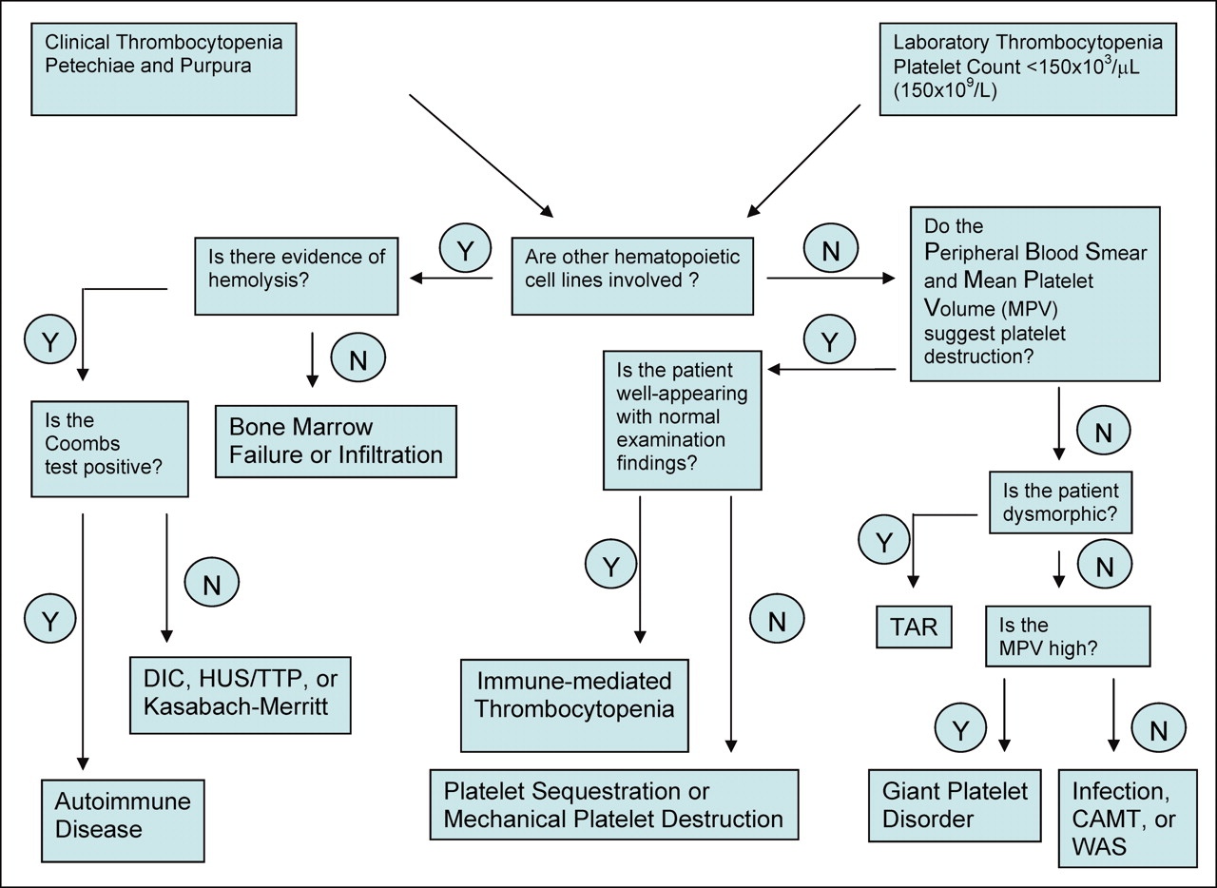
- Marques HO, Alexandre MAA, Oliveira VM, Marreira L, Lacerda MVG, Alecrim MGC, Morelli VM, Lourenço DM 2005. Hemostatic changes in patients with malaria. Annals of the XX Congress of the International Society on Thrombosis and Hemostasis, Sydney (Australia). J Thromb Haemost 3 (Suppl. I): 1452.
- Martin-Jaular L, Ferrer M, Calvo M, Rosanas-Urgell A, Kalko S, Graewe S, Soria G, Cortadellas N, Ordi J, Planas A, Burns J, Heussler V, Del Portillo HA 2011. Strain-specific spleen remodelling in Plasmodium yoelii infections in Balb/c mice facilitates adherence and spleen macrophage-clearance escape. Cell Microbiol 13: 109-122.
- Mast Q, de Groot PG, van Heerde WL, Roestenberg M, van Velzen JF, Verbruggen B, Roest M, McCall M, Nieman AE, Westendorp J, Syafruddin D, Fijnheer R, van Dongen-Lases EC, Sauerwein RW, van der Ven AJ 2010. Thrombocytopenia in early malaria is associated with GP1b shedding in absence of systemic platelet activation and consumptive coagulopathy. Br J Haematol 151: 495-503.
- Mast Q, Groot E, Lenting PJ, de Groot PG, McCall M, Sauerwein RW, Fijnheer R, van der Ven A 2007. Thrombocytopenia and release of activated von Willebrand Factor during early Plasmodium falciparum malaria. J Infect Dis 196: 622-628.
- Menendez C, Fleming AF, Alonso PL 2000. Malaria-related anaemia. Parasitol Today 16: 469-476.
- Mohanty D, Ghosh K, Nandwani SK, Shetty S, Phillips C, Rizvi S, Parmar BD 1997. Fibrinolysis, inhibitors of blood coagulation, and monocyte derived coagulant activity in acute malaria. Am J Hematol 54: 23-29.
- Mohanty D, Marwaha N, Ghosh K, Sharma S, Garewal G, Shah S, Devi S, Das KC 1988. Functional and ultrastructural changes of platelets in malarial infection. Trans R Soc Trop Med Hyg 82: 369-375.
- Mohanty S, Patel DK, Pati SS, Mishra SK 2006. Adjuvant therapy in cerebral malaria. Indian J Med Res 124: 245-260.
- Mohapatra MK, Padhiary KN, Mishra DP, Sethy G 2002. Atypical manifestations of Plasmodium vivax malaria. Indian J Malariol 39: 18-25.
- Monath TP 2001. Yellow fever: an update. Lancet Infect Dis 1: 11-20.
- Moulin F, Lesage F, Legros AH, Maroga C, Moussavou A, Guyon P, Marc E, Gendrel D 2003. Thrombocytopenia and Plasmodium falciparum malaria in children with different exposures. Arch Dis Child 88: 540-541.
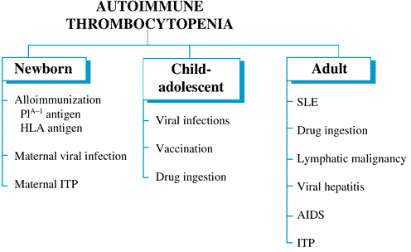
- Mourão MP, Lacerda MV, Macedo VO, Santos JB 2007. Thrombocytopenia in patients with dengue virus infection in the Brazilian Amazon. Platelets 18: 605-612.
- Mourão MPG, Lacerda MVG, Magalhães L, Alecrim WD, Alecrim MGC 2001. Estudo clínico em crianças internadas com malária (P. falciparum) na FMT-AM. Anais do XXXVII Congresso da Sociedade Brasileira de Medicina Tropical, Salvador. Rev Soc Bras Med Trop 34 (Suppl. 1): 71.
- Muniz-Junqueira MI 2007. Immunomodulatory therapy associated to anti-parasite drugs as a way to prevent severe forms of malaria. Curr Clin Pharmacol 2: 59-73.
- Muniz-Junqueira MI, Silva FO, de Paula Júnior MR, Tosta CE 2005. Thalidomide influences the function of macrophages and increases the survival of Plasmodium berghei-infected CBA mice. Acta Trop 94: 128-138.
- Murthy GL, Sahay RK, Srinivasan VR, Upadhaya AC, Shantaram V, Gayatri K 2000. Clinical profile of falciparum malaria in a tertiary care hospital. J Indian Med Assoc 98: 160-162.
- Nardi MA, Liu LX, Karpatkin S 1997. GPIIIa(49-66) is a major pathophysiologically relevant antigenic determinant for anti-platelet GPIIIa of HIV-1-related immunologic thrombocytopenia. Proc Natl Acad Sci USA 94: 7589-7594.
- Naveira JB 1970. Malária - aspectos hematológicos, Associate professorship Thesis, Universidade Federal do Rio de Janeiro, Rio de Janeiro, 104 pp.
- Nicodemo AC 1993. Análise de aspectos microscópicos, imuno-histoquímicos e ultra-estruturais do pulmão na leptospirose para a compreensão da patogenia da plaquetopenia, PhD Thesis, Universidade de São Paulo, São Paulo, 153 pp.
- Noronha EF 1998. Estudo clínico-epidemiológico da malária falciparum em crianças de 0 a 14 anos, atendidas no Instituto de Medicina Tropical do Amazonas em Manaus - AM - Brasil, MSc Thesis, Universidade de Brasília, Brasília, 126 pp.
- Oh MD, Shin H, Shin D, Kim U, Lee S, Kim N, Choi MH, Chai JY, Choe K 2001. Clinical features of vivax malaria. Am J Trop Med Hyg 65: 143-146.
- Ohtaka M, Ohyashiki K, Iwabuchi H, Iwabuchi A, Lin KY, Toyama K 1993. A case of vivax malaria with thrombocytopenia suggesting immunological mechanisms. Rinsho Ketsueki 34: 490-492.
- Pain A, Ferguson DJ, Kai O, Urban BC, Lowe B, Marsh K, Roberts DJ 2001. Platelet-mediated clumping of Plasmodium falciparum-infected erythrocytes is a common adhesive phenotype and is associated with severe malaria. Proc Natl Acad Sci USA 98: 1805-1810.
- Panasiuk A 2001. Autoimmune thrombocytopenia in recurrent polietiological malaria (Plasmodium falciparum, Plasmodium vivax). Wiad Parazytol 47: 85-89.
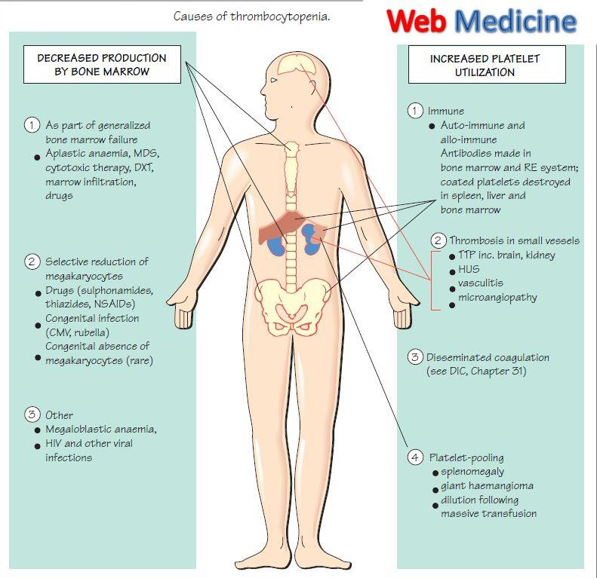
- Pankoui Mfonkeu JB, Gouado I, Fotso Kuate H, Zambou O, Amvam Zollo PH, Grau GE, Combes V 2010. Elevated cell-specific microparticles are a biological marker for cerebral dysfunctions in human severe malaria. PLoS ONE 5: e13415.
- Parakh A, Agarwal N, Aggarwal A, Aneja A 2009. Plasmodium vivax malaria in children: uncommon manifestations. Ann Trop Paediatr 29: 253-256.
- Park CHL, Ferreira CB, Bianchi CP, Fazio FS, Costa JC, Padilha A, Fonseca MO, Boulos M 2002. Plaquetopenia em pacientes com malária por Plasmodium vivax. Anais do XXXVIII Congresso da Sociedade Brasileira de Medicina Tropical, Foz do Iguaçu. Rev Soc Bras Med Trop 35 (Suppl. 1): 370.
- Park JW, Park SH, Yeom JS, Huh AJ, Cho YK, Ahn JY, Min GS, Song GY, Kim YA, Ahn SY, Woo SY, Lee BE, Ha EH, Han HS, Yoo K, Seoh JY 2003. Serum cytokine profiles in patients with Plasmodium vivax malaria: a comparison between those who presented with and without thrombocytopenia. Ann Trop Med Parasitol 97: 339-344.
- Patel U, Gandhi G, Friedman S, Niranjan S 2004. Thrombocytopenia in malaria. J Natl Med Assoc 96: 1212-1214.
- Peck-Radosavljevic M 2001. Hypersplenism. Eur J Gastroenterol Hepatol 13: 317-323.
- Piguet PF, Da Laperrousaz C, Vesin C, Tacchini-Cottier F, Senaldi G, Grau GE 2000. Delayed mortality and attenuated thrombocytopenia associated with severe malaria in urokinase- and urokinase receptor-deficient mice. Infect Immun 68: 3822-3829.
- Poespoprodjo JR, Fobia W, Kenangalem E, Lampah DA, Hasanuddin A, Warikar N, Sugiarto P, Tjitra E, Anstey NM, Price RN 2009. Vivax malaria: a major cause of morbidity in early infancy. Clin Infect Dis 48: 1704-1712.
- Prasad R, Das BK, Pengoria R, Mishra OP, Shukla J, Singh TB 2009. Coagulation status and platelet functions in children with severe falciparum malaria and their correlation of outcome. J Trop Pediatr 55: 374-378.
- Rasheed A, Saeed S, Khan SA 2009. Clinical and laboratory findings in acute malaria caused by various plasmodium species. J Pak Med Assoc 59: 220-223.
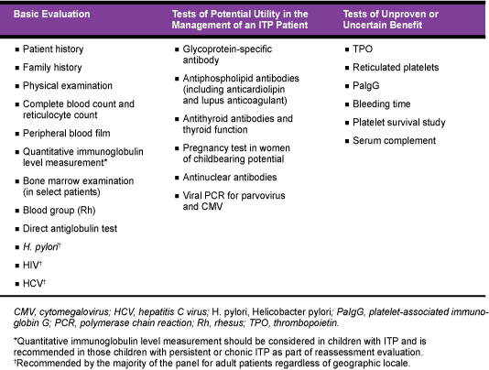
- Rebulla P 2000. Trigger for platelet transfusion. Vox Sang 78 (Suppl. 2): 179-182.
- Rebulla P 2001. Revisitation of the clinical indications for the transfusion of platelet concentrates. Rev Clin Exp Hematol 5: 288-310.
- Rifakis PM, Hernandez O, Fernandez CT, Rodriguez-Morales AJ, Von A, Franco-Paredes C 2008. Atypical Plasmodium vivax malaria in a traveler: bilateral hydronephrosis, severe thrombocytopenia, and hypotension. J Travel Med 15: 119-121.
- Rios-Orrego A, Alvarez-Castillo T, Carmona-Fonseca J, Blair-Trujillo S 2005. Temporal evolution of platelets and anti-platelet antibodies in patients of endemic area with non complicated malaria. An Med Interna 22: 561-568.
- Robinson P, Jenney AW, Tachado M, Yung A, Manitta J, Taylor K, Biggs BA 2001. Imported malaria treated in Melbourne, Australia: epidemiology and clinical features in 246 patients. J Travel Med 8: 76-81.
- Rodriguez-Morales AJ, Sanchez E, Vargas M, Piccolo C, Colina R, Arria M 2006. Anemia and thrombocytopenia in children with Plasmodium vivax malaria. J Trop Pediatr 52: 49-51.
- Rodriguez-Morales AJ, Sanchez E, Vargas M, Piccolo C, Colina R, Arria M, Franco-Paredes C 2005. Occurrence of thrombocytopenia in Plasmodium vivax malaria. Clin Infect Dis 41: 130-131.
- Rogier C, Gerardin P, Imbert P 2004. Thrombocytopenia is predictive of lethality in severe childhood falciparum malaria. Arch Dis Child 89: 795-796.
- Samuel H, Nardi M, Karpatkin M, Hart D, Belmont M, Karpatkin S 1999. Differentiation of autoimmune thrombocytopenia from thrombocytopenia associated with immune complex disease: systemic lupus erythematosus, hepatitis-cirrhosis, and HIV-1 infection by platelet and serum immunological measurements. Br J Haematol 105: 1086-1091.
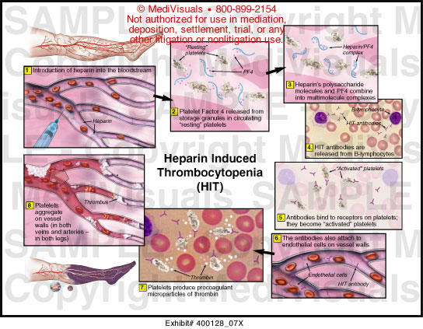
- Santana Filho FS, Arcanjo AR, Chehuan YM, Costa MR, Martinez-Espinosa FE, Vieira JL, Barbosa MG, Alecrim WD, Alecrim MG 2007. Chloroquine-resistant Plasmodium vivax, Brazilian Amazon. Emerg Infect Dis 13: 1125-1126.
- Santos MC, Lacerda MVG, Benedetti SM, Albuquerque BC, Aguiar Filho AA, Elkhoury MR, Rosa ES, Vasconcelos PF, Medeiros DB, Mourao MPG 2006. Human hantavirus infection, Brazilian Amazon. Emerg Infect Dis 12: 1165-1167.
- Santos PD 2000. Correlação entre níveis séricos de Intermediários Reativos de Nitrogênio (IRN) e malária em pacientes da Fundação de Medicina Tropical do Amazonas (FMT/IMT-AM), MSc Thesis, Universidade Federal do Amazonas, Manaus, 133 pp.
- Scaradavou A 2002. HIV-related thrombocytopenia. Blood Rev 16: 73-76.
- Schlossberg HR, Herman JH 2003. Platelet dosing. Transfus Apher Sci 28: 221-226.
- Shaikh QH, Ahmad SM, Abbasi A, Malik SA, Sahito AA, Munir SM 2009. Thrombocytopenia in malaria. J Coll Physicians Surg Pak 19: 708-710.
- Shear HL 1984. Murine malaria: immune complexes inhibit Fc receptor-mediated phagocytosis. Infect Immun 44: 130-136.
- Silva IBA 2004. Malária vivax: manifestações clínicas e laboratoriais relacionadas com o fator de necrose tumoral alfa, PhD Thesis, Universidade Federal do Pará, Belém, 128 pp.
- Silva SBR 2009. Avaliação da frequência e dos fatores associados à plaquetopenia causada pelo Plasmodium vivax, MSc Thesis, Universidade Federal do Mato Grosso, 64 pp.
- Silva SL, Santana Filho FS, Arcanjo ARL, Alecrim WD, Alecrim MGC 2000. Perfil clínico e hematológico dos pacientes internados com malária por Plasmodium vivax e plaquetopenia, na Fundação de Medicina Tropical do Amazonas, no período de janeiro de 1997 a setembro de 1999. Anais do XXXVI Congresso da Sociedade Brasileira de Medicina Tropical, São Luís do Maranhão , Rev Soc Bras Med Trop 33 (Suppl. 1): 348.
- Skudowitz RB, Katz J, Lurie A, Levin J, Metz J 1973. Mechanisms of thrombocytopenia in malignant tertian malaria. BMJ 2: 515-518.
- Song JY, Park CW, Jo YM, Kim JY, Kim JH, Yoon HJ, Kim CH, Lim CS, Cheong HJ, Kim WJ 2007. Two cases of Plasmodium vivax malaria with the clinical picture resembling toxic shock. Am J Trop Med Hyg 77: 609-611.
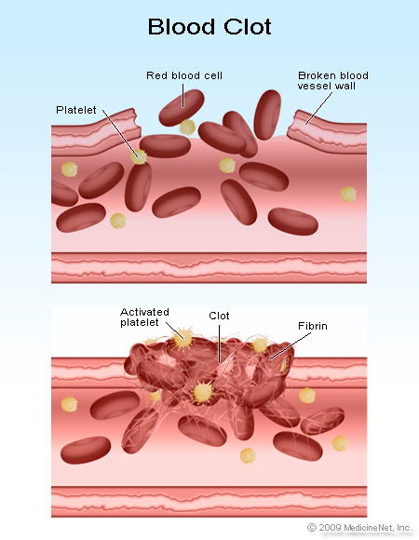
- Srichaikul T, Pulket C, Sirisatepisarn T, Prayoonwiwat W 1988. Platelet dysfunction in malaria. Southeast Asian J Trop Med Public Health 19: 225-233.
- Srichaikul T, Puwasatien P, Karnjanajetanee J, Bokisch VA, Pawasatien P 1975. Complement changes and disseminated intravascular coagulation in Plasmodium falciparum malaria. Lancet 1: 770-772.
- Srivastava S, Ahmad S, Shirazi N, Kumar Verma S, Puri P 2011. Retrospective analysis of vivax malaria patients presenting to tertiary referral centre of Uttarakhand. Acta Trop 117: 82-85.
- Suarez-Mutis MC, Cuervo P, Leoratti FM, Moraes-Avila SL, Ferreira AW, Fernandes O, Coura JR 2007. Cross sectional study reveals a high percentage of asymptomatic Plasmodium vivax infection in the Amazon Rio Negro area, Brazil. Rev Inst Med Trop Sao Paulo 49: 159-164.
- Sun G, Chang WL, Li J, Berney SM, Kimpel D, van der Heyde HC 2003. Inhibition of platelet adherence to brain microvasculature protects against severe Plasmodium berghei malaria. Infect Immun 71: 6553-6561.
- Takaki K, Aoki T, Akeda H, Kajiwara T, Honda S, Maeda Y, Okada K, Sawae Y 1991. A case of Plasmodium vivax malaria with findings of DIC. Kansenshogaku Zasshi 65: 488-492.
- Tan SO, McGready R, Zwang J, Pimanpanarak M, Sriprawat K, Thwai KL, Moo Y, Ashley EA, Edwards B, Singhasivanon P, White NJ, Nosten F 2008. Thrombocytopaenia in pregnant women with malaria on the Thai-Burmese border. Malar J 7: 209.
- Taylor WR, Widjaja H, Basri H, Ohrt C, Taufik T, Tjitra E, Baso S, Fryauff D, Hoffman SL, Richie TL 2008. Changes in the total leukocyte and platelet counts in Papuan and non Papuan adults from northeast Papua infected with acute Plasmodium vivax or uncomplicated Plasmodium falciparum malaria. Malar J 7: 259.
- Terrazzano G, Cortese L, Piantedosi D, Zappacosta S, Di Loria A, Santoro D, Ruggiero G, Ciaramella P 2006. Presence of anti-platelet IgM and IgG antibodies in dogs naturally infected by Leishmania infantum. Vet Immunol Immunopathol 110: 331-337.
- Thapa R, Biswas B, Mallick D, Sardar S, Modak S 2009. Childhood Plasmodium vivax malaria with severe thrombocytopenia and bleeding manifestations. J Pediatr Hematol Oncol 31: 758-759.
- Tjitra E, Anstey NM, Sugiarto P, Warikar N, Kenangalem E, Karyana M, Lampah DA, Price RN 2008. Multidrug-resistant Plasmodium vivax associated with severe and fatal malaria: a prospective study in Papua, Indonesia. PLoS Med 5: e128.
- Touze JE, Mercier P, Rogier C, Hovette P, Schmoor P, Dabanian C, Campiadgi S, Laroche R 1990. Platelet antibody activity in malaria thrombocytopenia. Pathol Biol (Paris) 38: 678-681.
- Tribulatti MV, Mucci J, Van Rooijen N, Leguizamon MS, Campetella O 2005. The trans-sialidase from Trypanosoma cruzi induces thrombocytopenia during acute Chagas' disease by reducing the platelet sialic acid contents. Infect Immun 73: 201-207.
- Tyagi P, Biswas S 1999. Naturally occurring plasmodia-specific circulating immune complexes in individuals of malaria endemic areas in India. Indian J Malariol 36: 12-18.
- Urban BC, Hien TT, Day NP, Phu NH, Roberts R, Pongponratn E, Jones M, Mai NTH, Bethell D, Turner GDH, Ferguson D, White NJ, Roberts DJ 2005. Fatal Plasmodium falciparum malaria causes specific patterns of splenic architectural disorganization. Infect Immun 73: 1986-1994.
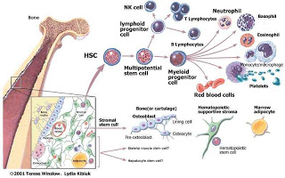
- Van der Heyde HC, Gramaglia I, Sun G, Woods C 2005. Platelet depletion by anti-CD41 (alphaIIb) mAb injection early but not late in the course of disease protects against Plasmodium berghei pathogenesis by altering the levels of pathogenic cytokines. Blood 105: 1956-1963.
- Victoria MB, Victoria F, Coelho AHV, Santos LO, Alecrim MGC 1998. Púrpura trombocitopênica em paciente com malária por Plasmodium vivax: relato de caso. Anais do XXXIV Congresso da Sociedade Brasileira de Medicina Tropical, Manaus. Rev Soc Bras Med Trop 31 (Suppl. 1): 55.
- Vij AS, Dandona PK, Aggarwal A 2008. Malaria with marked thrombocytopenia: report of 2 cases. J Indian Med Assoc 106: 123-125.
- Warrell DA, Looareesuwan S, Warrell MJ, Kasemsarn P, Intaraprasert R, Bunnag D, Harinasuta T 1982. Dexamethasone proves deleterious in cerebral malaria. A double-blind trial in 100 comatose patients. N Engl J Med 306: 313-319.
- Wassmer SC, Combes V, Candal FJ, Juhan-Vague I, Grau GE 2006a. Platelets potentiate brain endothelial alterations induced by Plasmodium falciparum. Infect Immun 74: 645-653.
- Wassmer SC, Lepolard C, Traore B, Pouvelle B, Gysin J, Grau GE 2004. Platelets reorient Plasmodium falciparum-infected erythrocyte cytoadhesion to activated endothelial cells. J Infect Dis 189: 180-189.
- Wassmer SC, Souza JB, Frere C, Candal FJ, Juhan-Vague I, Grau GE 2006b. TGF-beta1 released from activated platelets can induce TNF-stimulated human brain endothelium apoptosis: a new mechanism for microvascular lesion during cerebral malaria. J Immunol 176: 1180-1184.
- Watier H, Verwaerde C, Landau I, Werner E, Fontaine J, Capron A, Auriault C 1992. T-cell-dependent immunity and thrombocytopenia in rats infected with Plasmodium chabaudi. Infect Immun 60: 136-142.
- WHO - World Health Organization 2010. Guidelines for the treatment of malaria [homepage on the Internet]: 2010. Available from: whqlibdoc.who.int/publications/2010/9789241547925_eng.pdf.
- Wickramasinghe SN, Abdalla SH 2000. Blood and bone marrow changes in malaria. Baillieres Best Pract Res Clin Haematol 13: 277-299.
- Yamaguchi S, Kubota T, Yamagishi T, Okamoto K, Izumi T, Takada M, Kanou S, Suzuki M, Tsuchiya J, Naruse T 1997. Severe thrombocytopenia suggesting immunological mechanisms in two cases of vivax malaria. Am J Hematol 56: 183-186.

Ngày 19/8/2013
PGS.TS. Triệu Nguyên Trung và Ths.Bs. Huỳnh Hồng Quang

